**Experiment 6**

**Aim**  
Find synonyms and hyponyms using Python nltk and WordNet

Get all the hyponyms and hypernyms for a given word

Get all Hyponyms with synsetID

**Theory**

Wordnet is a large collection of words and vocabulary from the English language that are related to each other and are grouped in some way. That’s the reason WordNet is also called a

lexical database.

WordNet groups nouns, adjectives, verbs which are similar and calls them **synsets** or synonyms. A group of synsets might belong to some other synset. Synset is a special kind of a

simple interface that is present in NLTK to look up words in WordNet. Synset instances are the groupings of synonymous words that express the same concept. For example, the synsets

“Brick” and “concrete” belong to the synset “Construction Materials” or the synset “Brick” also belongs to another synset called “brickwork “. In the example given, brick and concrete are called hyponyms of synset construction materials and also the synsets construction material and brickwork are called synonyms.

**Code**

import nltk

from nltk.corpus import wordnet as wn

nltk.download("omw-1.4")

nltk.download("wordnet")

synonyms = []

word = "call"

for syn in wn.synsets(word):

    for i in syn.lemmas():

        synonyms.append(i.name())

print(f"Synonyms of {word} are: ")

print(set(synonyms), "\n")

hyponyms = []

print(f"Hyponyms of {word} are: ")

for syn in wn.synsets(word):

    for i in syn.hyponyms():

        hyponyms.append(i.name().split(".")[0])

print(set(hyponyms), "\n")

hypernyms = []

for syn in wn.synsets(word):

    # print(syn.hypernym_distances())

    for i in syn.hypernym_distances():

        hypernyms.append((i[0].name().split(".")[0], i[1]))

print(f"Hypernyms of {word} are: ")

print(set(hypernyms), "\n")

calls = wn.synset("call.n.01")

typesOfCalls = list(set([w for s in calls.closure(lambda *s*: s.hyponyms()) for w in s.lemma_names()]))

print(f"Hyponyms of Synset ID {calls} are: ")

print(set(typesOfCalls))

**Output**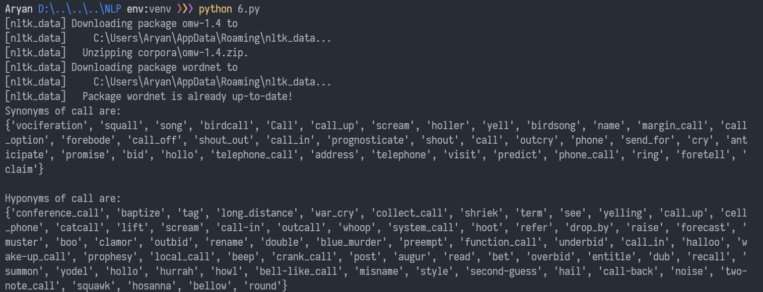

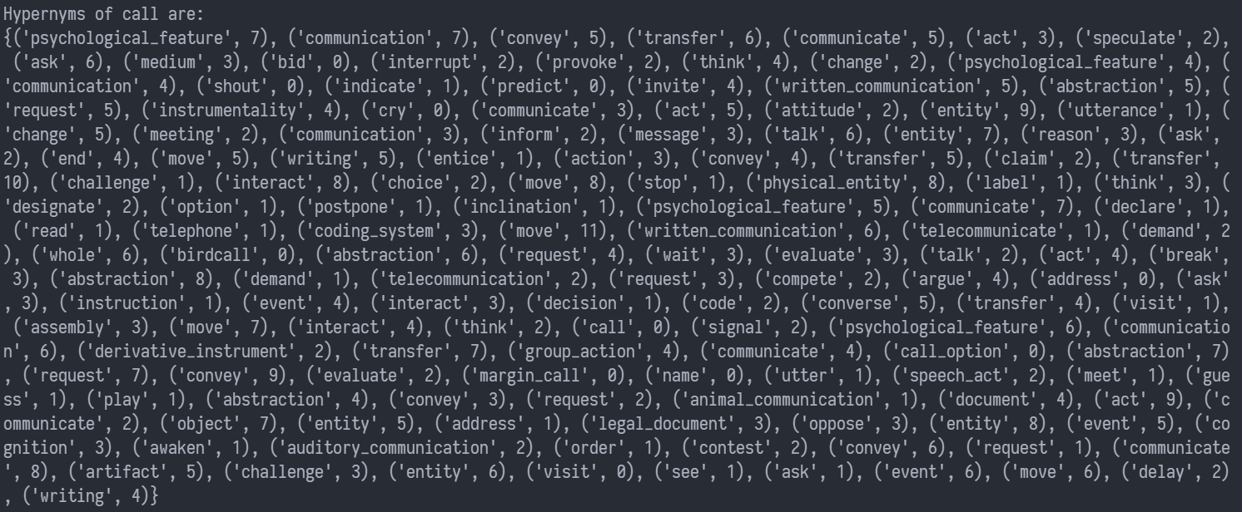



**Conclusion**Hence, word sense disambiguation has been performed using WordNet and NLTK.